**Atmega328p Microcontroller**

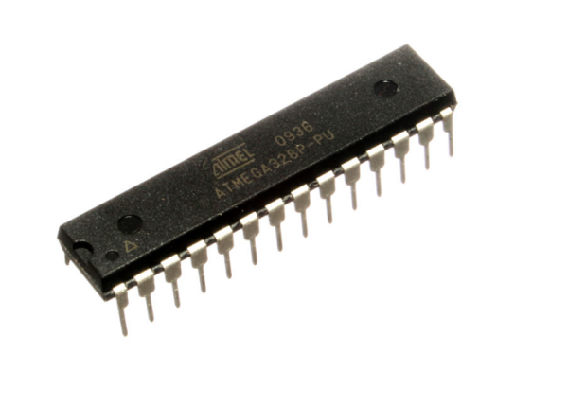

**ATmega328p**is an eight (8) bit micro-controller. It can handle the data sized of up to eight (8) bits. It is an AVR (Advanced Virtual RISC) based micro-controller. Its built-in internal memory is around 32KB. It operates ranging from 3.3V to 5V. It has an ability to store the data even when the electrical supply is removed from its biasing terminals. Its excellent features include the cost efficiency, low power dissipation, programming lock for security purposes, real timer counter with separate oscillator. ATmega-328 is shown in the figure given below.

**Atmega328p pins**

* ATmega-328 is an AVR micro-controller having twenty eight (28) pins. 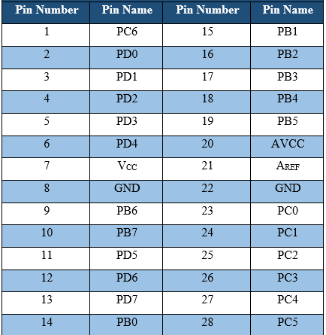

**Atmega328p pin out**

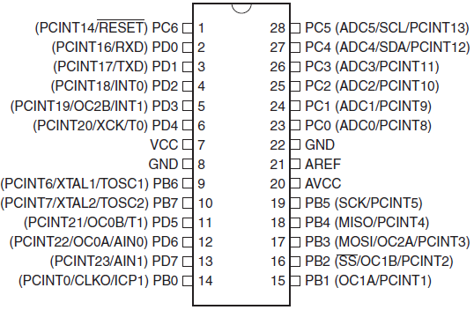

**Atmega328p pin description**

Functions associated with the pins must be known in order to use the device appropriately.ATmega-328 pins are divided into different ports.

* **VCC**is a digital voltage supply.
* **AVCC**is a supply voltage pin for Analog to digital converter.
* **GND**denotes Ground and it has a 0V.
* **Port A**consists of the pins from **PA0**to**PA7.**These pins serve as analog input to analog to digital converters. If analog to digital converter is not used, **port** **A**acts as an eight (8) bit bidirectional input/output port.
* **Port B**consists of the pins from **PB0**to**PB7.**This port is an 8 bit bidirectional port having an internal pull-up resistor.
* **Port C**consists of the pins from **PC0**to**PC7.**The output buffers of **port C**has symmetrical drive characteristics with source capability as well high sink.
* **Port D**consists of the pins from **PD0**to**PD7.** It is also an 8 bit input/output port having an internal pull-up resistor.
* **AREF**is an analog reference pin for analog to digital converter.
* All of the AVR ports are shown in the figure given below.

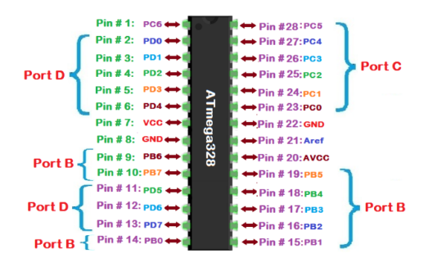

**Atmega328p Features**

* To perform any task we can select a device on the basis of its features. i.e whether its features match to obtain the desired results or not.
* Some of the main features of an AVR micro-controller ATmega328 are shown in the table given in the figure below.

[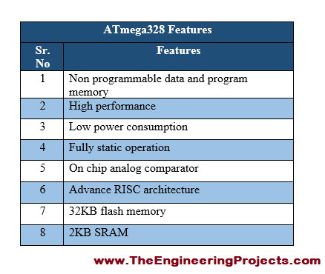](https://www.theengineeringprojects.com/wp-content/uploads/2017/07/Introduction-to-Atmega328_5.png)

### Features

* 28-pin AVR Microcontroller
* Flash Program Memory: 32 Kbytes
* EEPROM Data Memory: 1 Kbytes
* SRAM Data Memory: 2 Kbytes
* I/O Pins: 23
* Timers: Two 8-bit / One 16-bit
* A/D Converter: 10-bit Six Channel
* PWM: Six Channels
* RTC: Yes with Separate Oscillator
* MSSP: SPI and I²C Master and Slave Support
* USART: Yes
* External Oscillator: up to 20MHz